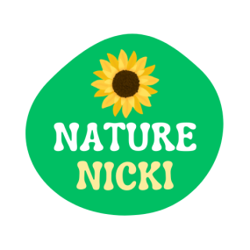

**Payments & Refunds Policy**

* Payments must be made in advance or upon receipt of an invoice.
* Our sessions carry on in all weathers, excepting those considered to pose an adverse risk, such as high winds or thunderstorms (please see our weather policy). In such an event, the session will be cancelled or rearranged.
* If the session leader has to cancel due to illness or unforeseen circumstances then the session will be cancelled or rearranged.
* Refunds will be issued if sessions are cancelled by Nature Nicki Forest School or payment transferred to a different session.
* Refunds are not given for child illness or no shows.
* Cancellation with expectation of a refund for a session must be made at least 48 hours before the start of the booked session.

Payment to be made by bank transfer to:

Nicola Townsend

Account: 01150066

Sort code: 071096

Created on: 01/01/2025 by Nicola Townsed

Review date: January 2026